Game Design Document

Fill up the Following document

1. Write the title of your project.

Snake Game

1. What is the goal of the game?

For entertainment and for enhancing observation skill

1. Write a brief story of your game?

There is a player name called pappu who will eat enemies and after eating enemies , he will become big and big and at the same time he should protect himself from being touched by his own body.

1. Which are the playing characters of this game?

* Playing characters are the ones which respond to the user based on the input from the user
* Cars, monkeys, dinos, wizards etc, are the playing characters in the game.

|  |  |  |
| --- | --- | --- |
| Number | Character Name | What can this character do? |
| 1 | Pappu | Eating Enemies and protecting himself from obstacles and enemies. |

1. Which are the Non Playing Characters of this game?

* Non Playing characters are the ones which don't have an action or a behaviour when the user interacts with the game.
* Hurdles, stones, bananas, coins, etc are non playing characters in the game.

|  |  |  |
| --- | --- | --- |
| Number | Character Name | What can this character do? |
| 1 | Enemies | Nil |
| 2 | Obstacles | It can harm the player |
| 3 | Background Image | Just for look |

Draw your imagination of this game. What does this game look like?

* Draw the game either on your computer or on paper,
* Add images of scenes of the game to show each of the playing and non-playing characters at least once.

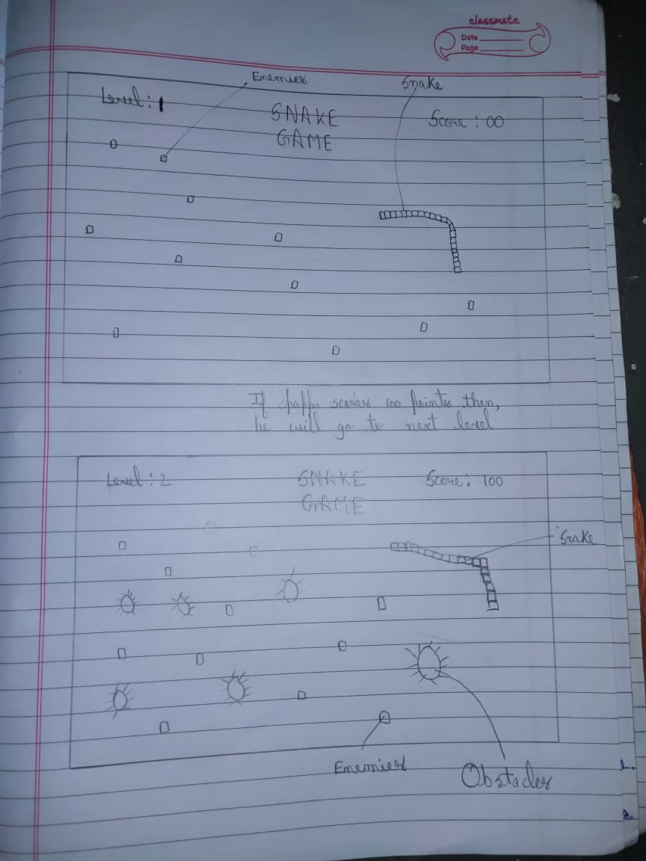

How do you plan to make your game engaging?

Level1-The user will play the game using the character pappu and once user reaches to 100 score user will go to next level

Game will be more engaging because obstacles are added to make game more difficult and interesting

I’ll also add sounds and different animations